Metric QA Agent v2 (former Swivel Sync) Requirements Checklist

Overview

Objective: Empower non-technical users to compare, sync, and audit metrics across multiple disparate data files by intelligently mapping schemas and flagging discrepancies based on user-defined thresholds. (Note: combines features from Ashley’s Claude agent with those of existing Swivel Sync agent.)
Users: All of Horizon – any internal stakeholder who wants to compare values and flag inconsistencies across two or more data files

Requirements

In-Scope:
- File Ingestion:
  - Allow users to upload two or more source files (Excel or CSV)
  - Allow users to access files on Sharepoint.
  - Allow users to filter/subset rows per source before comparison (e.g., keep only "Display" channel in one report, exclude certain dates). Filters apply keep-only or exclude modes by column value.

- Schema Mapping:
  - Users specify which spreadsheet tab it should parse if there are multiple tabs
  - Automatically parse and display column headers for each file
  - Users specify metrics for comparison and match keys
  - Save, re-use, and export schema mapping configuration for future use
  - Smart column matching: When you load a saved setup from before, the tool automatically looks for those same columns in your new files. If a column is missing, it tells you so you can pick a different one.

- Threshold Definition:
  - Allow users to define match key i.e., rows that are compared if these values are equal
  - Allow users to define which columns to compare
  - For 3 or more files, allow user to designate whether agent should compare everything to one baseline or compare every source vs every source
  - For each metric compared, allow users to define a threshold (Ashley’s current build has “Flag if off by more than [x] % or [x] units”)
  - Flag compared values that do not match e.g., “Values do not match; Mismatch in Columns A and C vs B””
  - Flag values that are blank in specified metric column e.g., “Not in Source A; Not in Source B; In Source A and B, not C; etc..”
- Output Generation:
  - Generate report containing only rows with flags
    - Include Summary of # of rows that have no match “e.g., 117 rows in Source A have no match in Source B”
    - Include Table with Row-Level Info: Include Columns for Match Key, Flag, Metrics by Source, Differential
  - Filter results table: After running the comparison, filter what you see by:
    - Specific key values (like "Client A" only)
    - Hide rows where everything is zero
  - Allow user to export output as an Excel or CSV file
  - Two reset options: "Clear results" (keeps your files and settings so you can try again) vs. "Start over" (go back to the beginning)

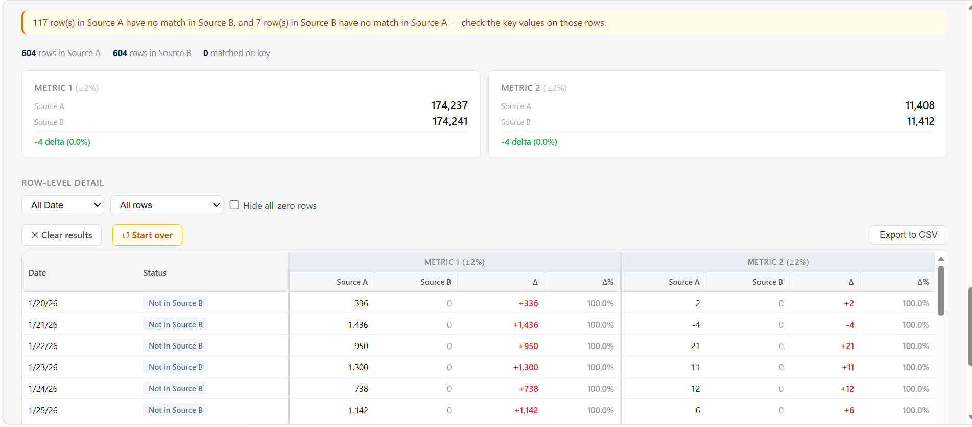

Out-of-Scope:
- Agent will not perform auto-correction or adjust original source files in any way; it is read-only
- Agent will compare data only on rows where match keys are identical
- Agent is limited to comparing existing data and will not create new metrics

Human In Loop:
- Agent is interactive and workflow is human-in-the-loop by design.
- Agent relies on human confirmation for different steps (e.g., files/tabs to parse, match keys to join, metrics to compare, thresholds to flag, file to use as baseline)
- Flag if there is an error reading a file/column and why

Acceptance Criteria:
- Successfully ingest and parse any valid Excel/CSV
- LLM-guided schema accurately identifies file column headers
- Output report correctly flags 100% of rows that do not pass user-defined thresholds
- Final report is correctly formatted and contains all columns specified (tbd)

